**Azure Assignment**

**(AZ – 104- Module 3)**

**Avishekh Sinha**

# Module 3 - Storage Account

## ASSIGNMENT 1

**1. Create a storage account**

**2. Connect storage explorer to this storage account**

1. Create a storage account

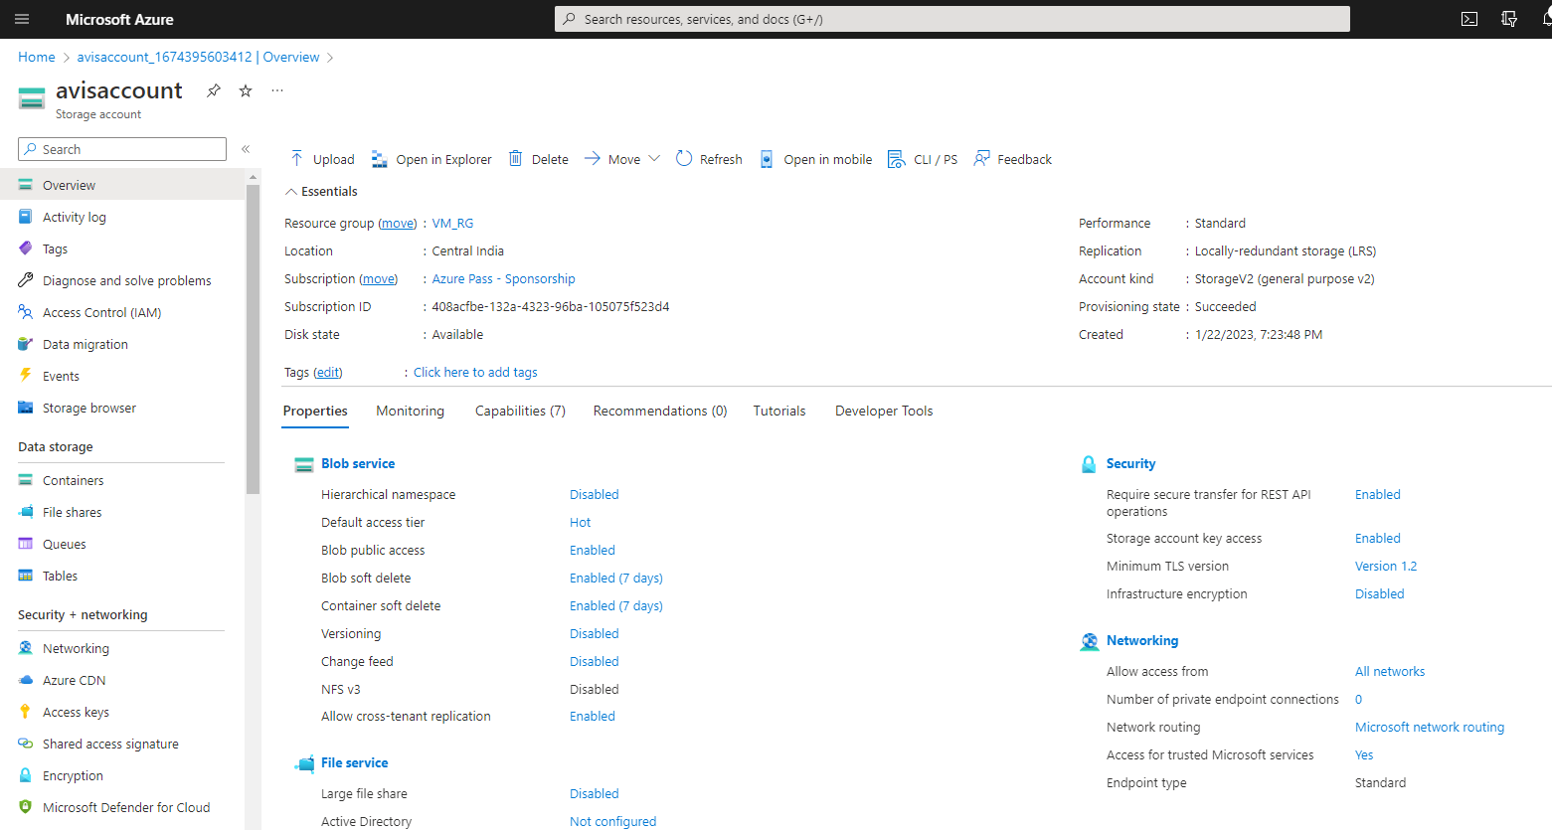

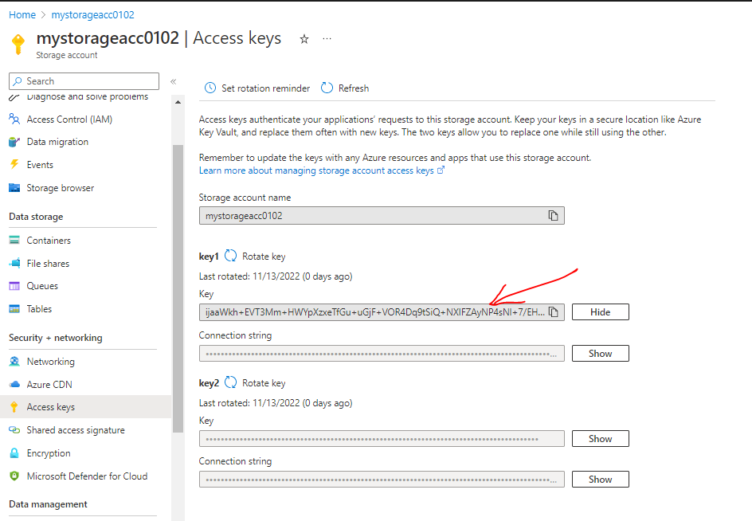

1. Connect storage explorer to this storage account
2. CONNECTION USING AZURE ACCOUNT

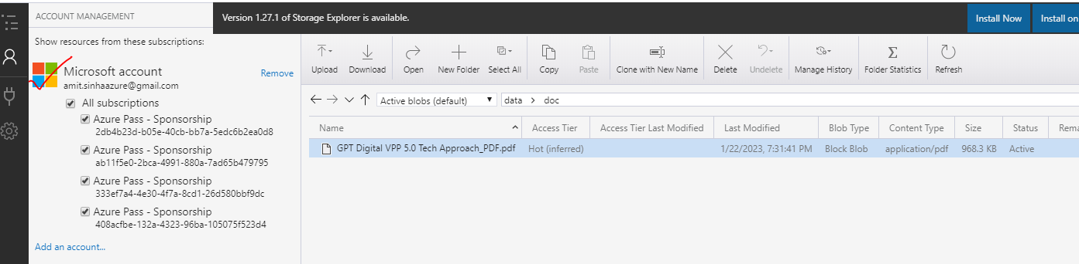

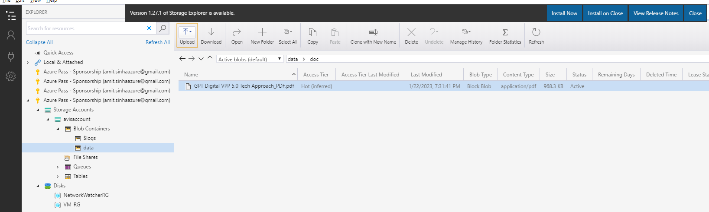

1. CONNECTION USING ACCESS KEY

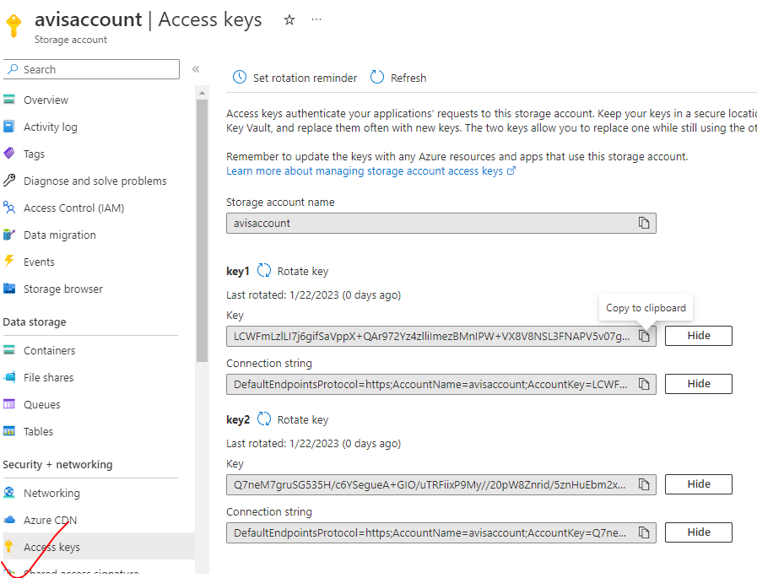

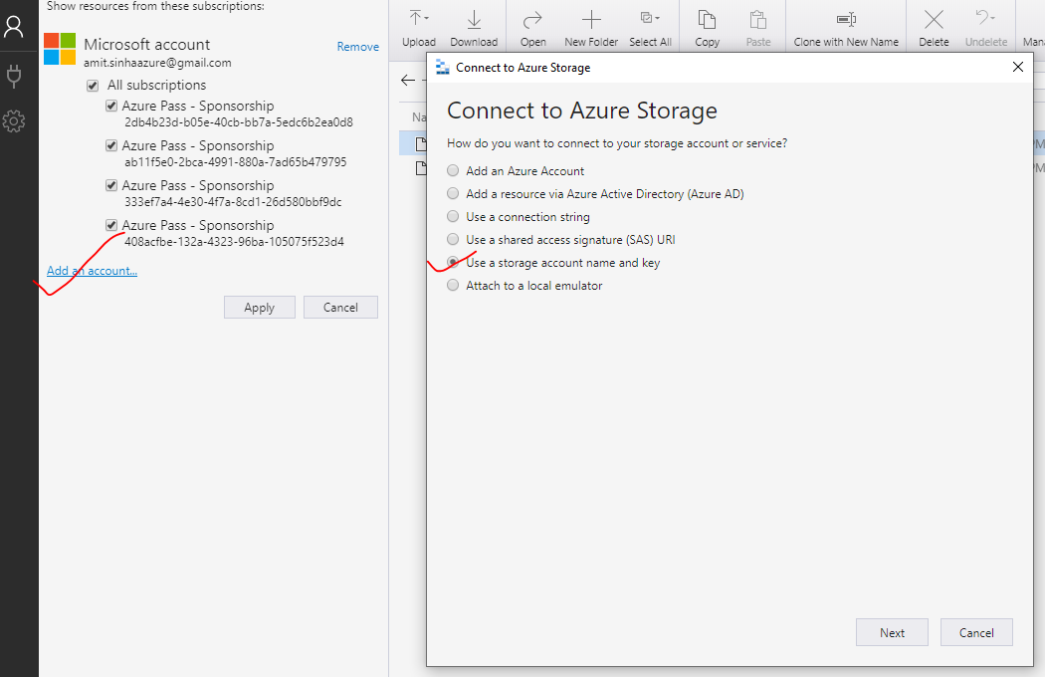

* **Paste the access key and account name 🡪 Next**

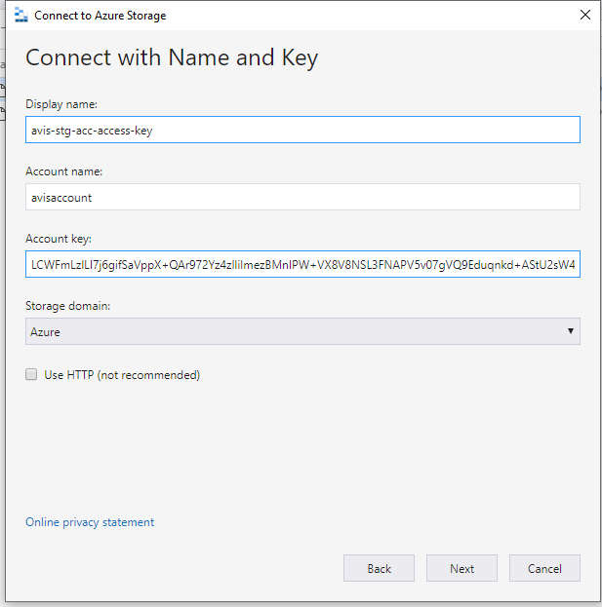

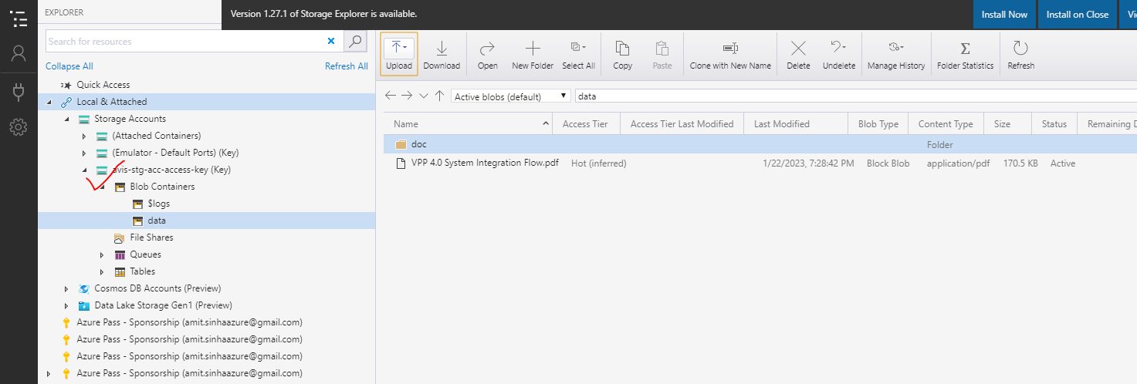

## ASSIGNMENT 2

**1. Create a Fileshare using the Storage explorer**

**2. Upload files to the blob service**

**3. Create an Azure Table and insert a record**

CREATE A FILESHARE USING THE STORAGE EXPLORER

Step 1-

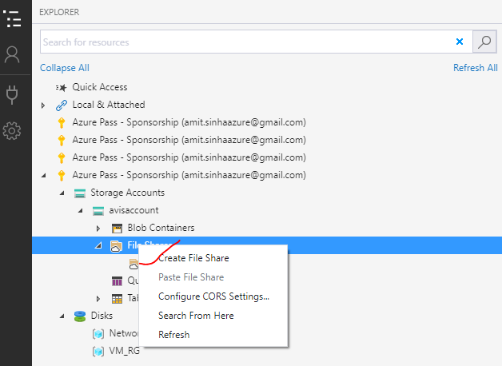

Step 2:

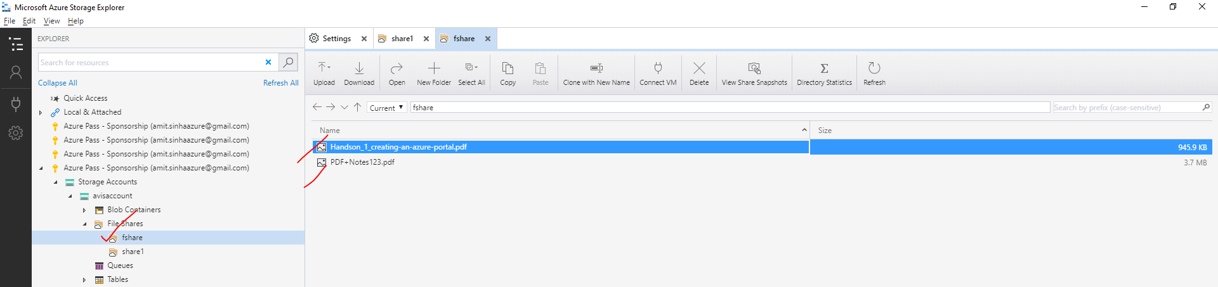

1. UPLOAD FILES TO THE BLOB SERVICE

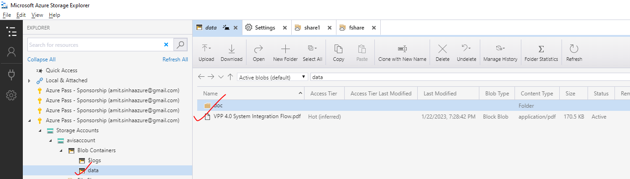

CREATE AN AZURE TABLE AND INSERT A RECORD

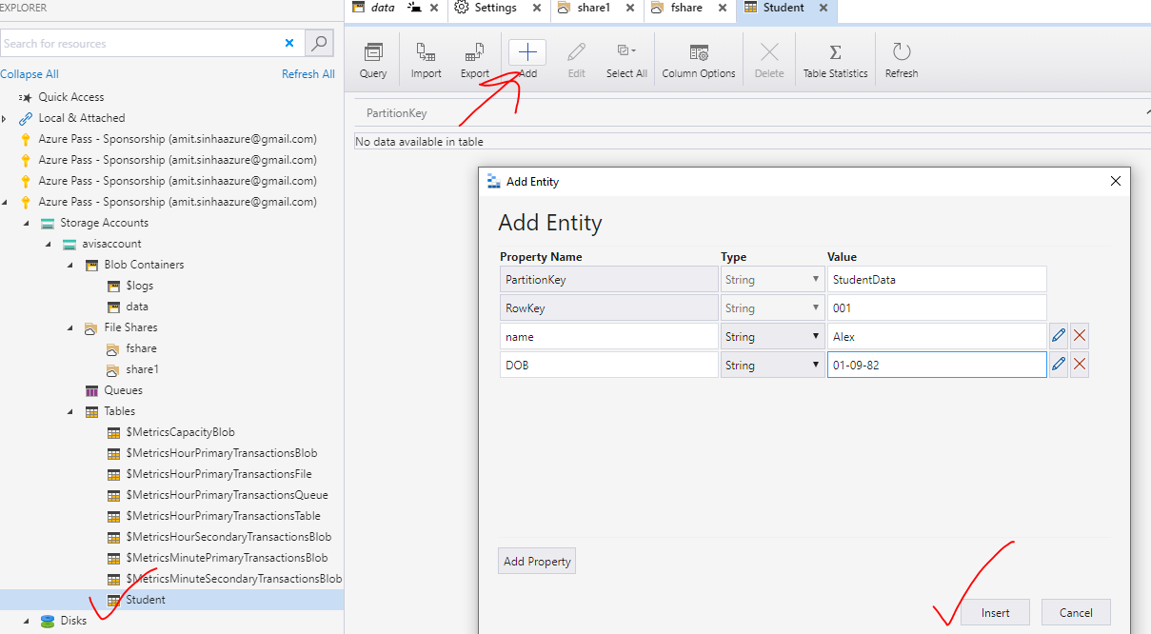

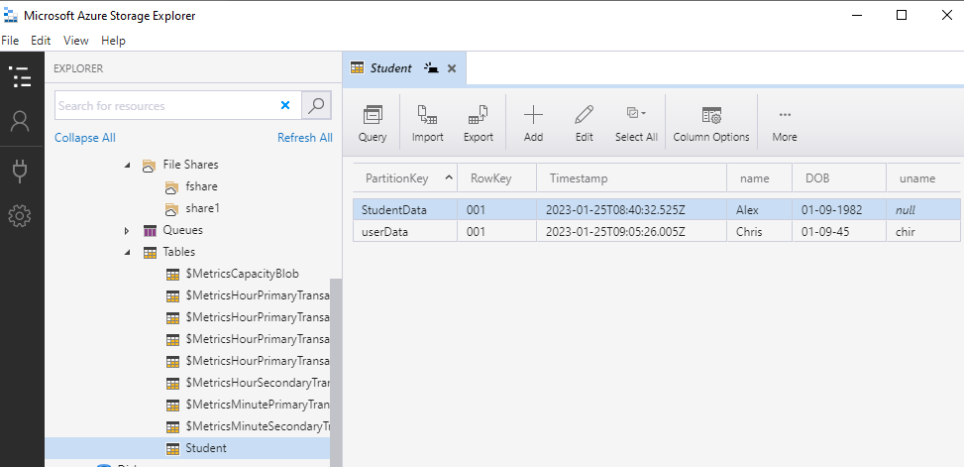

## ASSIGNMENT 3

**1. Create two storage account and create a container inside it**

**2. Upload some data to the first Blob service**

**3. Using Data Factory copy data to the second storage service’s container**

## ASSIGNMENT 4

**1. Use the same storage accounts from previous assignment**

**2. Use azcopy utility to copy data from one storage container to another**